Level Three ‘Extensive Preview’ Reading Passages

Contents

Frequently Asked Questions (FAQs)**1**

The Plastic Bag that Disappears **3**

Factory Farming**5**

Who Put the Lag in Jet Lag?**7**

# FAQs

# What are these?

They are 3 reading passages. One of these will be in the Mid Term Exam that you will take in about 6 weeks. We are calling this part of the exam an ‘Extensive Preview’ test – *extensive*  means ‘a lot’ and *preview* means ‘see something before you need to’. The idea behind this is that you get to see what you are going to be tested on, long before the exam. You will not know which reading will be used so you will have to read them all. And you will not know what the questions are until the day of the exam. The marks for the exam will count towards your L3 grade. We will repeat this in the second half of the semester. You will also answer a few questions (5) in your first and second Computer Generated Exams (CGEs). CGE 1 will have questions on Reading 1. CGE 2 will have questions on Readings 1, 2 and 3.

# Why are we doing this?

To help you. This gives you a chance to get higher grades through your own work. Also, we think that if you work on the Extensive Preview Readings, your reading ability generally will improve. We particularly want your reading ability to improve since our scores in the IELTS exam are worse in reading than in any other part. More people fail to get Band 5 IELTS because of reading than any other part of the exam.

# What should you do with them?

Work on them independently and with your friends. You will not get any help in class. Your teacher will concentrate on your regular course. This part of your course is *independent learning.*

You should do the following things:

Read the passages carefully and do everything you need to do to understand them. A good way of working is from big to little; try to understand:

* The overall topic
* What the writer is saying about the topic
* The main points
* What the topic of each paragraph is
* What the sentences mean
* What the words mean

# Will these readings be the only things tested in the Midterm exam?

No, there will be some *Preview Listenings* too. There will also be some reading passages and listenings that you have never seen or heard before. All together there will be 3 parts of the exam (two listenings and one reading) that you will have heard or seen before: questions on these will add up to almost half of the marks in the Mid Term Exam. In the CGEs there will be a few questions on these passages but most of the questions will be on vocabulary and grammar.

# So, what will the Mid Term Exam be like?

Your Midterm Exam will have 6 parts, 3 of which you can work on before the exam:

1. ***Preview Listening 1: a dialogue / conversation that you have heard before***
2. ***Preview Listening 3: a short presentation/lecture that you have heard before***
3. Listening 3: a short presentation/lecture that you have ***NOT*** heard before, that

you will hear twice.

1. Reading Task 1: a short ‘Understanding Graphics’ reading exercise that you have

***NOT*** seen before

1. ***Preview Reading Task 2: a reading passage that you have seen before – i.e. one of the readings in this booklet***
2. Reading Task 3: a reading passage that you have ***NOT*** seen before

# *Work hard and good luck!*

Paragraph Topics Reading 1

Which paragraphs are about what?

Check it our!

|  |  |
| --- | --- |
| Topic | Paragraph |
|  |  |
|  |  |
|  |  |
|  |  |
| Lots of plastic bags made here! |  |
|  |  |
|  |  |
|  |  |

Reading 1: The plastic bag that disappears

1. Some environmentalists have called for a total ban on plastic bags and when you look at the 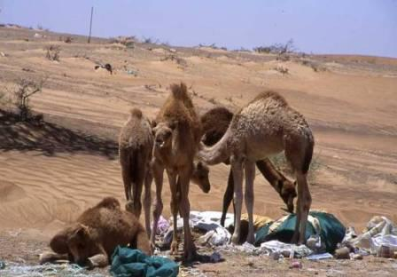figures for their production, you can understand why. The UAE is a relatively small country and yet here 48 million plastic bags are made every month at just one factory, Al Ain Plastics. This amounts to 600 tonnes worth of plastic bags, produced, consumed and, probably, thrown away every month. If these are the figures for one factory in a small country, what are the figures like for the whole world? An accurate answer is difficult but estimates range from 500 billion to 1 trillion per year. What is more, plastic bags can take up to 1,000 years to biodegrade. These rates of production coupled with the incredibly long life of these bags add up to an environmental nightmare.

2. In the UAE, this issue was brought vividly to the public’s attention when the fate of wild camels came to light. Many of them eat plastic bags, thinking that they are food. Apparently, the bags do a good job of killing the camels’ appetites but unfortunately, over time, they also kill the camels since they form large indigestible balls in the camels’ stomachs, which prevent the ingestion of real food and eventually starve the camels to death. Obaid Al Matroushi, Director General of the Ministry for Environment and Water, said recently that it is estimated that one out of every two camels in the desert die in this way.

3. To help deal with this problem, the plastics industry has come up with an additive that breaks down the plastic bag totally. The plastic is mixed with a small amount of a chemical called d2w. This causes them to become *oxo-biodegradable.* Unlike normal plastic bags, oxo-biodegradable carriers disintegrate into nothing more than water, carbon dioxide and a very small amount of biomass.The bags degrade completely - regardless of location or environmental conditions - and have a pre-programmed lifespan of a few months rather than a thousand years.

4. Al Ain Plastics factory recently partnered with Wells Plastics from the UK to supply them with the additive, which they call Reverte. "We've been giving quotes for two types of bag - normal and oxo-biodegradable (oxo). The difference in cost is just 25 fils per kilo”, said Kausar Ali Shah, procurement officer at Al Ain Plastics. Even then not everybody opts for oxo, he says. "It is not easy to convince people even though it is in our interest and in the environment's interest. It is their choice but it will work better when they don't have a choice. Hypermarkets are easier to convince, they are also more informed. Smaller chains or independent stores have [](http://www.google.ae/imgres?q=plastic+bags+pollution+in+UAE&start=20&hl=en&sa=N&biw=1024&bih=601&gbv=2&tbm=isch&tbnid=wUl74lYruq5XLM:&imgrefurl=http://www.dulsco.com/Newsletter/IndexVol02Iss04.htm&docid=oBSoCd9wTneYGM&imgurl=http://www.dulsco.com/PageImages/Image/WMS%20Newsletter%20Images/enewsletter08/plasticbagban.jpg&w=462&h=308&ei=aFkqT4f8NtGYOpr6lIoO&zoom=1)smaller budgets."

5. Al Ain Plastics now boasts that 60 per cent of its production is made to biodegrade and disappear. Big supermarket chains like Carrefour, Safeer and Lulu and some cooperatives make up the bulk of Al Ain Plastic's clientele. Carrefour orders 100 tonnes, Safeer in Sharjah orders between 20 to 25 tonnes and Lulu supermarkets in Al Ain are down for between 15 to 20 tonnes. These supermarkets and others, such as Megamart, Cooperative and Geant have already switched entirely to the new biodegradable bags. If you do your shopping there, you will find a statement printed in green on their plastic bags that they are OXO-biodegradable.

6. Other shops and supermarkets will probably wait until legislation comes through at a federal level, according to Shah. By 2013, non-biodegradable plastic shopping bags will be banned t[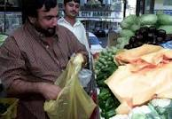](http://www.google.ae/imgres?q=plastic+bags+pollution+in+UAE&start=15&hl=en&sa=N&biw=1024&bih=601&gbv=2&tbm=isch&tbnid=egHFNv_cdIQ1bM:&imgrefurl=http://gulfnews.com/news/gulf/uae/environment/plastic-bags-do-not-biodegrade-for-hundreds-of-years-academic-1.91900&docid=kCdXt0NTAuuHKM&imgurl=http://gulfnews.com/polopoly_fs/18-ae-plastic-bags-5-jpg-1.88218!image/2461685099._gen/derivatives/box_475/2461685099.&w=475&h=328&ei=aFkqT4f8NtGYOpr6lIoO&zoom=1&iact=rc&dur=32&sig=116668203873182293071&page=2&tbnh=128&tbnw=165&ndsp=20&ved=1t:429,r:12,s:15&tx=90&ty=72)hroughout the UAE. Ajman Emirate has already banned them, making them illegal in June 2010.

7. Some other countries recognized the need to do something about plastic bags earlier than the UAE. In South Africa, where they used jokingly to call the plastic bag, the ‘national flower’, the government passed legislation in 2007 requiring supermarkets to make plastic bags more durable and more expensive. Since then there has been a 90% drop in plastic bag production. The Irish also had a humorous name for the plastic bag – they called it the ‘national flag’. There the government acted even earlier, imposing a tax of 15 Eurocents per bag in 2002. This led to a 95% reduction in their use.

8. Hopefully, other countries will soon follow these examples. In the 1990’s it was discovered that there is a ‘soup’ of plastic trash floating in the Pacific Ocean between America and Japan. This patch of plastic soup is the size of Texas. Much of this is made up of plastic bags. Millions of sea creatures every year are killed by ingesting or getting tangled up with plastic. It is thought that the near disappearance of sea turtles in many oceans is the result of plastic bags, since they mistake them for jellyfish, which are a large part of their diet. Like the camels of the UAE, they eat the plastic bags instead of their natural food, and die.

Adapted from Gulf News, The Khaleej Times and Worldwatch.org

<http://www.khaleejtimes.com/DisplayArticle08.asp?xfile=data/theuae/2010/February/theuae_February160.xml&section=theuae>

<http://gulfnews.com/news/gulf/uae/environment/the-plastic-bag-that-disappears-1.57525>

<http://www.worldwatch.org/node/1499>

Reading 2: Factory Farming

1. 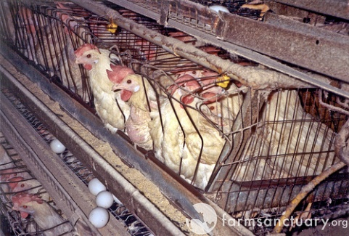Have you ever looked at your McDonald’s chicken sandwich and wondered where the meat came from? There’s a good chance that it came from chickens raised on a factory farm. Factory farms, or CAFOs (**C**oncentrated **A**nimal **F**eeding **O**perations), produce much of the [meat](http://en.wikipedia.org/wiki/Meat), [milk](http://en.wikipedia.org/wiki/Milk) and [eggs](http://en.wikipedia.org/wiki/Egg_(food)) eaten by people in the world today. The unique characteristic of CAFOs is the high concentration of livestock, or animals. That is, they differ from traditional farms because they keep large numbers of animals - typically cows, sheep, turkeys, or chickens - in very crowded conditions and often indoors. The aim of the operation is to produce as much meat, eggs, or milk as possible at the lowest possible cost. In this way, a farm functions like a [factory](http://en.wikipedia.org/wiki/Factory).
2. Factory farming began in the U.S. in the 1920s, soon after the discovery of vitamins A and D. When these vitamins are added to feed, animals no longer need exercise and sunlight for growth. This allowed large numbers of animals to be raised indoors all year-round. An advantage of this was that food could be given to the animals where they were kept so they didn’t have to go outside to be fed or to find food. This saved space and money. A problem that arose when animals were kept close together like this for long periods was the much increased spread of disease. This problem was also solved with drugs when antibiotics were developed in the 1940s. In addition to these pharmaceutical methods of increasing food production farmers used machines and production techniques in the same way as they are used in factories. Animals were kept in small pens or cages to control their movements and breeding programs were used to create animals that had more meat and are more suited to the crowded living spaces. This further increased animal production and lowered cost.
3. 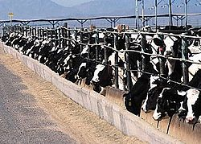In the 1960s, sheep and cows began to be raised on CAFOs. This way of farming then spread to Western Europe. From its American and West European center, factory farming became globalised in the later years of the 20th century. It is still growing and replacing traditional practices of livestock rearing in an increasing number of countries. In 1990, factory farming accounted for 30% of world meat production. By 2005 this had risen to 40%. Today, CAFOs account for 67% of poultry meat production and 50% of egg production worldwide. If you include fish farming, 99% of the animal production in the U.S. today comes from factory farms.
4. Factory farming has both pros and cons. The two main advantages of factory farms are greater meat, egg and dairy production at a lower cost. Both of these mean lower prices in the supermarket. Given the number of meat eaters on the planet today and the projected rise in meat consumption as the planet’s population grows, factory farming would seem the perfect answer. However, the list of disadvantages is quite long.
5. Firstly, CAFOs use up important natural resources. Instead of being eaten by people, most of the grain grown in the U.S. is fed to farm animals. This wasteful and inefficient practice has forced factory farms to exploit huge areas of land. Forests, wetlands, and other natural ecosystems and wildlife habitats have been destroyed in order to make space to house animals and grow the plants they eat. Furthermore, fossil fuels, groundwater, and nutrient-rich soil, which took thousands of years to develop, are now disappearing.
6. Another significant issue is the quantity of waste produced by farm animals in the U.S. It is more than 130 times greater than that produced by 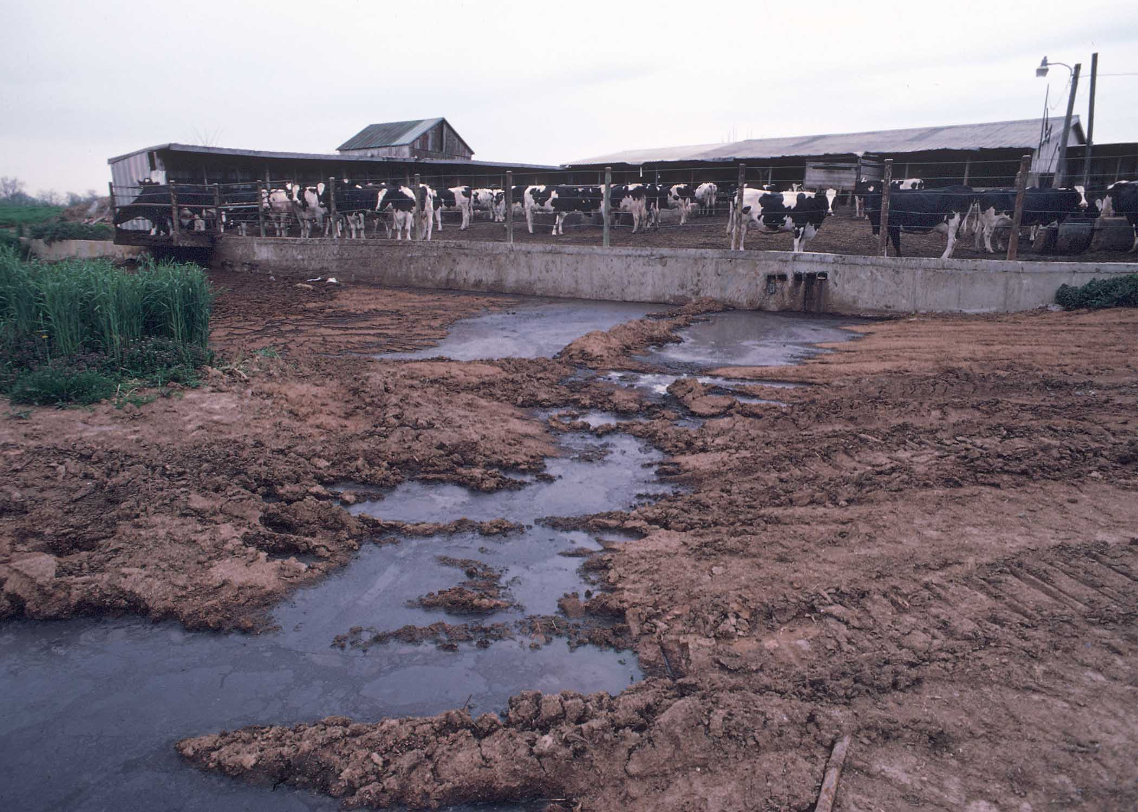humans! Agricultural runoff, or waste products from factory farming, has killed millions of fish, and is the main reason why 60% of America's rivers and streams are "damaged". In states with CAFOs, the waterways have become overloaded with *pfiesteria* bacteria. In addition to killing fish, *pfiesteria* causes open sores, nausea, memory loss, tiredness and confusion in humans. Even the water under the ground (groundwater) is being polluted. For example, the water table under the San Bernadino Dairy Preserve in southern California contains more nitrates and other pollutants than water coming from sewage treatment plants.
7. Lastly, this trend of mass production has resulted in unnatural pain and suffering for the animals. They are kept in small cages with metal bars, in rooms with dirty air and non-natural lighting, or no lighting at all. In many CAFOs claws, beaks and tails are removed in order to prevent damage from the biting and scratching that occurs in the crowded conditions. Although the factory farming systems give humans a steady supply of cheap meat, it is a sad fact that the cost of this is that animals are not considered animals at all; they are food-producing machines.

Text adapted from:

<http://www.idausa.org/facts/factoryfarmfacts.html>

<http://en.wikipedia.org/wiki/Factory_farming>

<http://www.idausa.org/facts/factoryfarmfacts.html>

<http://www.worldwatch.org/node/5443>

Reading 3: Who Put the Lag in Jet Lag?

1. 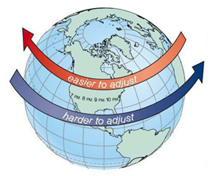Traveling around the world to learn about new cultures, hear different languages and taste new foods is generally a wonderful experience. However, there is one aspect of international travel that is decidedly negative – jet lag. ‘Jet lag’ is the term used to describe any of the health problems experienced when we fly across more than three or four time zones. The symptoms of jet lag are the same the world over — tiredness, inability to sleep, confusion, swelling of hands and feet, loss of appetite and headaches. Jet lag may also contribute to nausea, sore throat, a decrease in thinking skills and a lowered resistance to illness. The severity of the symptoms often depends on how far we fly, the direction in which we are heading (most people find it easier to fly east to west) and the time of departure. The more time zones we cross, the longer it takes for the body to adjust to its new time patterns.

1. Flying more frequently does not help reduce the symptoms of jet lag. Airline pilots who continually fly halfway around the world and back generally feel 'out of sorts' much of the time. Company executives who spend more time in the air than in the office never really adjust to constantly changing time zones. Sports players who regularly compete abroad need to allow at least a week to get their body clocks back to the right time. This can affect their performance on the playing field.
2. 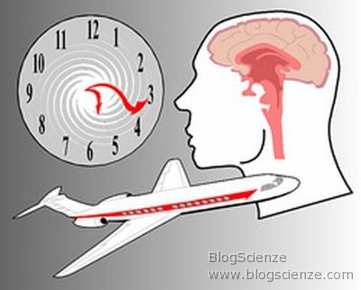Jet lag is thought to be connected to a disturbance in the body’s internal clocks, a condition known as *circadian desynchronization*. Nearly every living creature has a circadian system whose rhythms control the timing of many aspects of biochemistry, physiology and behavior. It is this natural cycle that causes people to feel tired at night time and awake during daylight hours. Our body temperature, too, is affected by our circadian system; it naturally falls at night and rises in the day. Other examples of human body structure influenced by the circadian system include heart rate and blood pressure.
3. Scientists believe that the source of the circadian system is probably in a small structure of approximately 16,000 neurons - called the suprachiasmatic nuclei (SCN) - in the brain. The SCN neurons are responsible for the rhythm that controls the crucial rest-activity cycle; this rhythm matches the solar cycle of 24 hours. The SCN neurons make use of a light-sensing pigment called melanopsin, found in cells located in the eye. This pigment reacts to light signals. Basically, the SCN is like the manager of the circadian system, giving instructions that coordinate the many parts of our bodies. When all the parts work together, we feel rested and well. When they do not, for example on a long-haul flight, we can feel terrible. How this system works is not fully understood by doctors and scientists, and is the subject of much research.

1. We do know, however, that crossing time zones in a jet plane disconnects these rhythms from the natural day-night cycle. To minimize jet lag, travelers can pick from any number of measures. Some people use special diets; others prepare for long flights by changing pre-flight sleep and wake times to lessen the symptoms. A hormone called melatonin is a popular remedy, though some health professionals doubt its benefit. At least one top researcher favors seeking (or avoiding) sunlight after the plane lands in order to match the body’s clock with local time. However, probably the best thing to do if you often take long flights is to visit your doctor, who can help you work out a plan that is right for you.
2. Although there is no magic pill to take away the effects of jet lag, some recent studies on “jet lagged” mice suggest that help for this problem may be coming. Giles Duffield of the University of Notre Dame, with colleagues at Dartmouth Medical School and Norris Cotton Cancer Center, modified the Id2 gene in some mice. They then watched the mice over several weeks, under different light/dark schedules, and recorded their activity. Changing the day to night schedules of the mice caused a 10-hour delay in the usual mouse circadian cycle, which is equal to a person flying from Athens to Los Angeles. Normal mice took about four or five days to return to their usual activity routine. But the mice who had the modified Id2 gene adapted twice as fast and were back to normal in only one to two days. Of course, mice and humans are different, and altering the Id2 gene in humans would be very difficult.
3. Clearly, jet lag is a complicated condition, both in the range of symptoms that it causes and the various remedies and lifestyle changes travelers can choose in order to reduce its effect. Of course not everyone suffers from jet lag, but for people who have to travel regularly as part of their work it can affect the quality of their daily lives. Non-essential air travelers - those who fly long distances on vacation - need to weigh up the excitement of traveling abroad with the possible discomfort caused by jet lag.

Adapted from [www.nytimes.com](http://www.nytimes.com) April 14, 2009, by Leon Kreitzman