Mid-term VTL Revision: Verbs

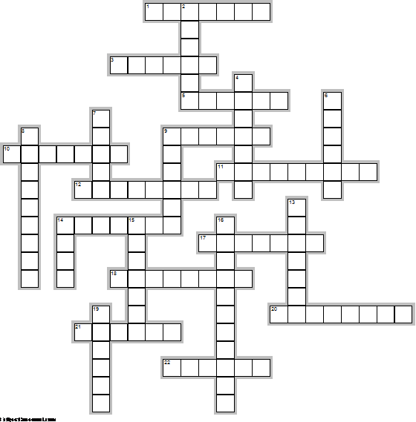

Across

1. Become black or make black. "Soldiers _______ thier faces so that they won't be seen at night."
3. Like something more than another thing. "I ------ coffee to tea."
5. Take away. "Please ______ your hand from my arm."
9. Help. "The nurse's job is to ______ the doctor during the operation."
10. Regularly watch and check something. "Today, doctors use machines to _______ people's heartbeat and blood pressure etc."
11. Make something start to exist or happen. "Business studies will show you how to _________ your own company."
12. To know what something or who someone is by using evidence. "You need to bring your ID card to the exam so that we can ________ you."
14. Need. "Car hire companies _______ you to show them your driver's licence."
17. React, reply, do something because something else has been done. "If someone says 'Thank you', you can _______ by saying, 'You're welcome.' "
18. Think about, have an opinion about. "________ your answer carefully." "Most people today ________ that education is the right of every child."
20. Show, point out, suggest. "Recent figures ________ that prices have started to fall."
21. Influence or change somethng in some way. "Coffee and tea ______ me differently. Coffee makes me nervous and tea makes me relaxed."
22. Keep, don't lose. "Our workers are good. We don't want to lose them. We want to ______ them."

Down

2. Seem / look like, begin to be seen. "You ______ to be tired. Would you like to rest." "During Add-drop, students ______ and disappear daily."
4. Be made of something. "Fresh vegetables _______ mostly of water."
6. Get (something you need by following a process). "To ______ a universtiy degree, you must follow a university course."
7. Try to keep away from (doing) something. "You shouldn't look for trouble, you should try to _____ it."
8. Build, make (something big or complicated with a number of parts. "People _________ buildings, ships, models and sentences."
9. To like and respect. "People ______ Nelson Mandela because he gave so much for what he believed."
13. To say something (but not spend much time on it). "Two paragraphs _______ animals in zoos but the main topic is animals in the wild."
14. Need, depend on. "Doctors today ____ on machines. They could not do their work without them."
15. Include, be part of. "UGRU courses _______ lots of hard work and independent study."
16. Get worse. "Without maintenance, buildings ___________."
19. Have enough money to buy something. "I want a bigger car but I cannot ______ one at the moment."

