**Mid-term VTL Revision – Adjectives**



**Across**

2. To do with real things you can see or touch, like the body but not the mind. "There was no ________ evidence that he committed the crime, only opinions, so the police let hm go."

4. In a situation where people or animals can be hurt; in danger of becoming extinct (dying out). "The tiger is one __________ species that we do not want to lose."

7. Large, noticeable, Important. "There has been a ___________ increase in world temperatures in the last 100 years."

8. Correct or true in every detail. "Architects need to make ________ drawings of their buildings so that the builders build them correctly."

10. Every year. "The ______ meeting this year will take place on May 13th."

11. Enjoying making people or animals feel pain or feel sad. "My big brother was quite _____ to me when he was younger but now he is kind."

14. Allowed by rules to do something. "You will be ________ for the UGRU IELTS exam when you pass Level 3."

15. Very, very good. "You get a _________ view of Al Ain and the Rub al Khali from the top of Jebel Hafeet."

17. Of lines - the same distance from each other; similar. "The road and the railway line are ________ for many kilometres."

**Down**

1. Needing a lot of hard physical work or energy. "Running up a sand dune is very _________ exercise."

3. Making sense, connecting ideas or reasons in an intelligent way. "That 2+2=5 is not _______." "She presented her ideas in a clear and _______ way."

5. Storing or processing information as numbers / in a computerised form. "Is that an analogue camera or a _______ camera?"

6. Giving people more time or money than they expect. "My father is a ________ man; he always gives me money when I go out."

7. Different in a good way. "The wedding meal is a _______ meal for a _______ occasion."

9. To do with education. "We teach ________ English to help students understand the English in their university courses."

12. The same in some way(s). "People think they are twins because they look so _______."

13. Very, very important; so important that it makes a big difference. "Vitamins are _______ to health."

16. Very, very small. "Microbes are ____ animals, so small they cannot be seen."

**Mid-term VTL Revision – Adjectives - Key**

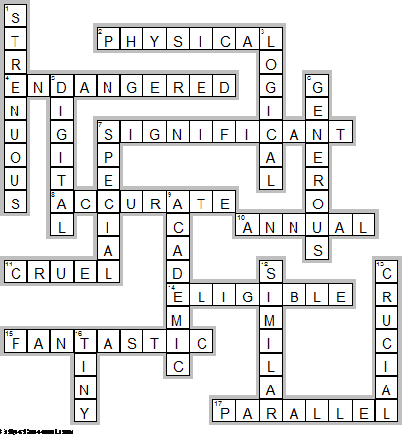

Mid term crossword grid for Word Adjectives (key).wmf